**Venn Diagram Probability Practice Name_____________________________**

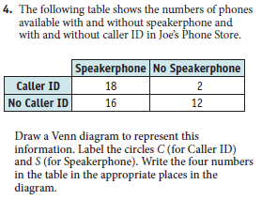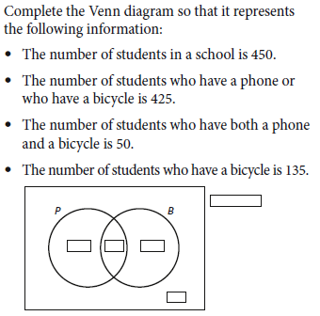 **Date___________________Period_____**

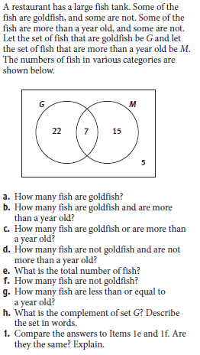







7 and 8.





