Probability Review Name:_____________________________

Date:_________Hr:_______

1) Alvin forgot the passcode for his phone. He remembers that he used the digits 1 – 4 to create the four number passcode. He does not remember in what order or if he used all digits from 1 – 4. Create the sample space for Alvin’s passcode.

2) Without creating the sample space, how could you have calculated the number of possible passcodes?

3) Health officials in Milwaukee, Wisconsin, were concerned about teenagers with asthma. People with asthma often have difficulty breathing. In a local research study, researches collected data on the incidence of asthma among students enrolled in a Milwaukee public high school.

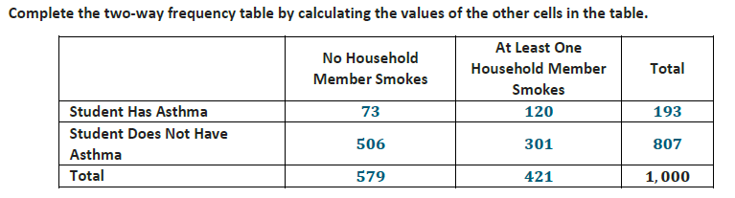

4) In a class of 30 students, 19 study Physics, 17 study Chemistry and 15 study both of these subjects. Display this information on a Venn diagram and determine the probability that a randomly selected class member studies:

1. both subjects



1. at least one of the subjects
2. Physics, but not Chemistry
3. Exactly one of the subjects

1. Neither subject

5) **Make use of structure**. Use the terms *complement,* *intersection*, and/or *union* to describe each combination of sections in the Venn.

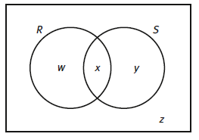

a. w and z

b. w and y

c. z

d. x and z

e. y and z