Period, Amplitude, Midline and the Cosine Function Name:___________________________

Use a graphing device (Calculator or Desmos), your understanding of the Unit circle, and what you know about transformations of functions to make connections between the graphs and the standard form of the sine function.
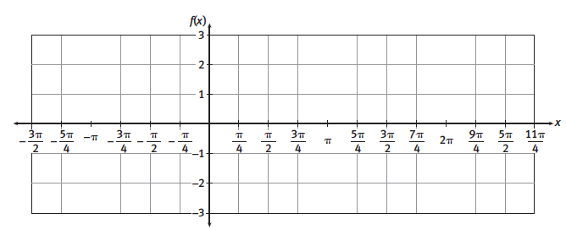
1) y = cos x

2) y = cos x + 1

3) y = 3 cos x

4) y = cos $\frac{1}{2}x$

5) y = cos (x$- π)$

6) Consider the function of the form $y=A cos\left[B\left(x-C\right)\right]+D$

a. What is the amplitude?

b. What is the period?

c. Which parameters can cause a vertical stretch or shrink? Be specific about how.

d. Which parameters causes a horizontal shift? Be specific about how.

e. Which parameters causes a vertical shift? Be specific about how.

